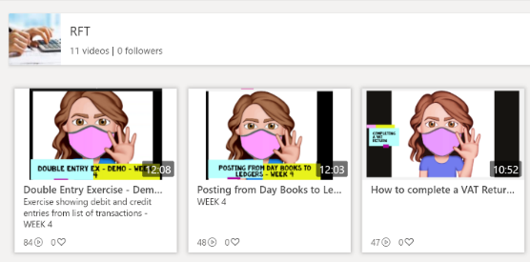
Delivery of RFT
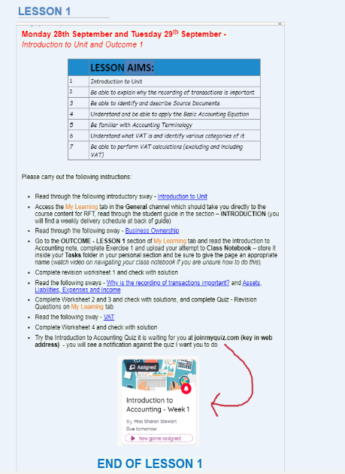
- To support all live lessons, I created short videos on skills student were to master eg posting from day books to ledgers; each day book was recorded separately, this allowed lessons to be chunked up and in my opinion helped to improve retention of information and increase engagement.

- I used Class Notebook to store all my Lesson plans – all Lessons Plans were created in advance of delivery allowing students to access learning materials in an orderly manner. Giving students control of their Learning with some even looking at materials in advance of classes, giving them a great understanding during delivery and improving flexibility of delivery.
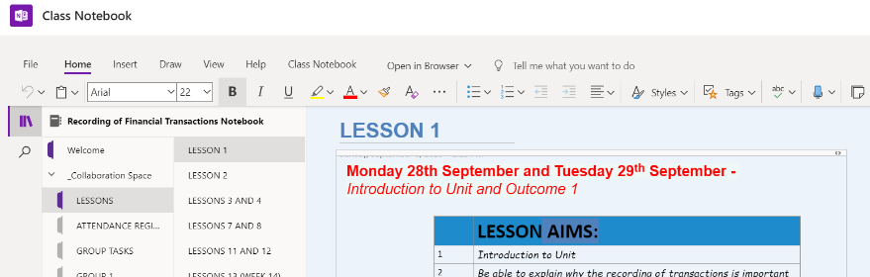
- All lessons were delivered live – at beginning of session I would have half the class in and the other half joining remotely – virtual classroom was created. This helped to sharpen all student digital skills.

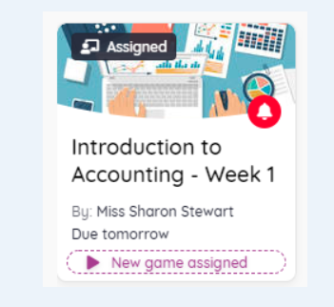
- All lessons were recorded which allowed students who may have missed lessons to go back and watch at a later day/time so no learning was ever missed.

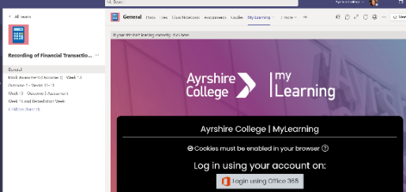
- Use of Quizzes to support knowledge and understanding covered in each section of learning. Helping students to identify gaps in their learning and by practicing retrieval of information after learning it made them more likely to retain it for longer.

- My Learning embedded in Team page so everything in one place giving easy access to materials.

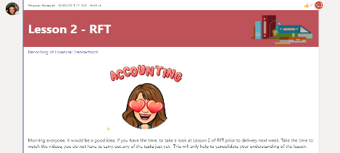
- Use of Bitmojis within my Team page to create and build a colourful virtual environment making it a welcoming environment

- Ensuring recorded lessons are stored in weekly channels making it easy for students to find.
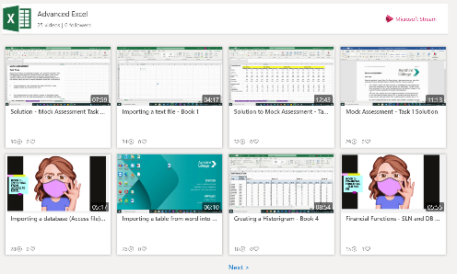
Delivery of Advanced Excel/Advanced Database
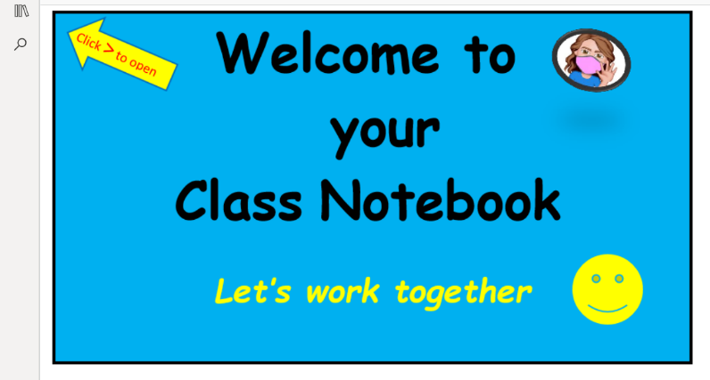
- To support all live lessons I created short videos on each skill student was to master eg using financial functions; creating a pivot table etc this allowed lessons to be chunked up and in my opinion helped to improve retention of information and increase engagement.

- I used Class Notebook to store all my Lesson plans – all Lessons Plans were created in advance of delivery allowing students to access learning materials in an orderly manner. Giving students control of their Learning with some even looking at materials in advance of classes, giving them a great understanding during delivery and improving flexibility of delivery.
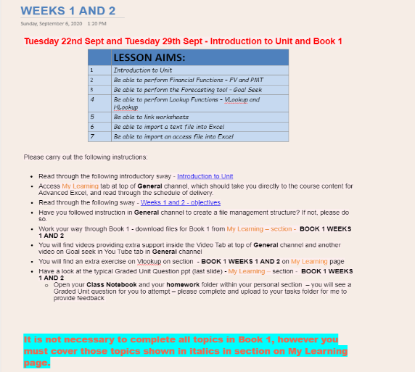
- All lessons were delivered live – virtual classroom was created. This helped to sharpen all student digital skills.
- All lessons were recorded which allowed students who may have missed lessons to go back and watch at a later day/time so no learning was missed
- Had one-to-one team meetings with students if struggling with any feature and they were encouraged to share screen with me where I would watch them demonstrate a function/feature and help support them with it – just as I would do in the classroom
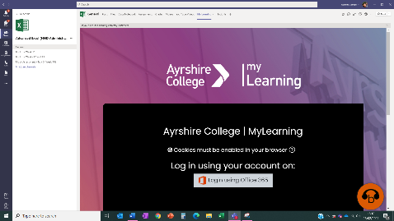

- My Learning embedded in Team page so everything in one place, making it easy for students to locate resources.

- Use of quizzes to support knowledge and understanding covered in unit – encouraging motivation and engagement – making learning fun! Helping students to identify gaps in their learning and by practicing retrieval of information after learning it made them more likely to retain it for longer.
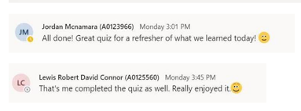
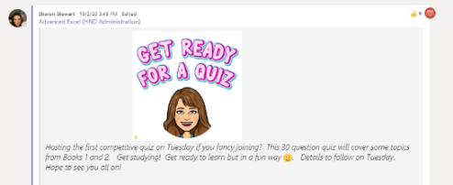
- Many students enjoyed the quizzes - see examples of feedback from students across various groups.
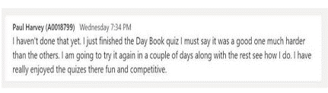

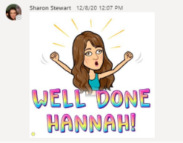

- Use of Bitmojis within my Team page to create and build a
colourful virtual environment making it a welcoming environment.

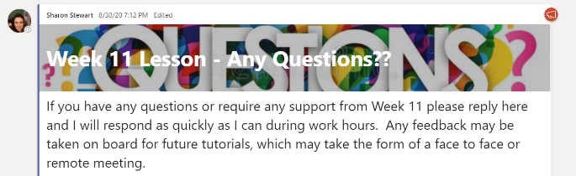
- Encourage feedback from class through Team posts – keeping all feedback in one area supports full class.

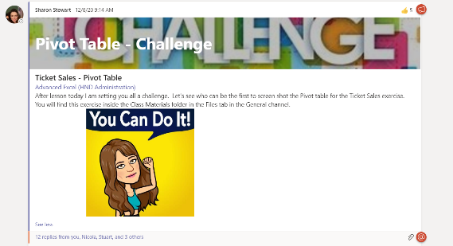
- Ensuring recorded lessons are stored in weekly channels

- Set group challenges through team posts to encourage engagement and maintain motivation and build team community.

Delivery of Office Admin
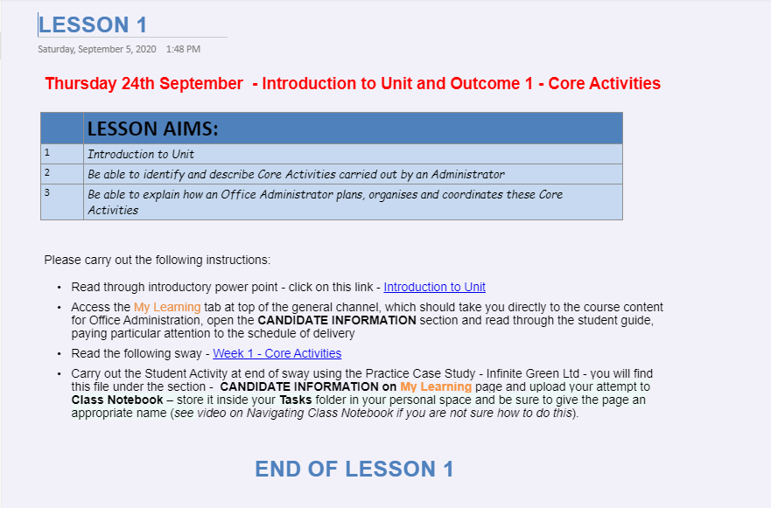
- I used Class Notebook to store all my Lesson plans – all Lessons Plans were created in advance of delivery allowing students to access learning materials in an orderly manner. Giving students control of their Learning with some even looking at materials in advance of classes, giving them a great understanding during delivery and improving flexibility of delivery.
- All lessons were delivered live – virtual classroom was created. This helped to sharpen all student digital skills.
- My Learning embedded in Team page so everything in one place, making it easy for students to locate resources.
- Use of Bitmojis within my Team page to create and build a colourful virtual environment making it a welcoming environment for all students.
- Ensuring recorded lessons are stored in weekly channels making it easy for students to find.
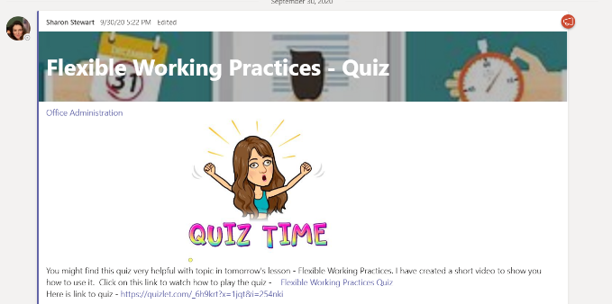
- Use of quizzes to support knowledge and understanding covered in unit – encouraging motivation and engagement – making learning fun! Helping students to identify gaps in their learning and by practicing retrieval of information after learning it made them more likely to retain it for longer.
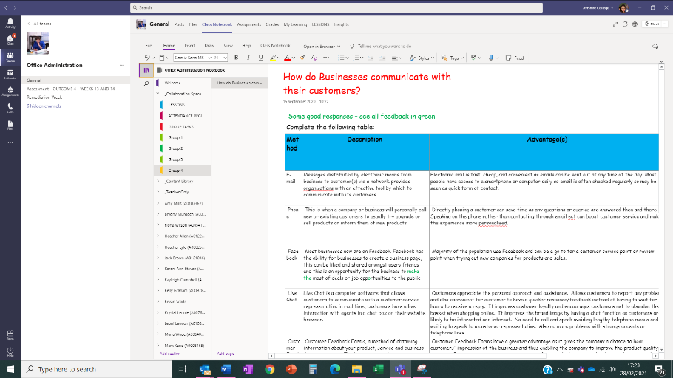
- Set up Class Notebook to provide a collaboration space to allow students to work in groups and collaborate on tasks. This helped to build relationships in class and allowed students to make individual progress in tandem with others in their group, all working towards a common goal. This helped to make them accountable to one another and encouraged them to self-manage their tasks. – flipping the classroom.

Delivery of DTfA
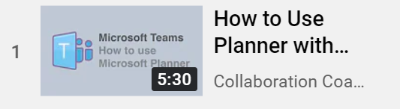
- To support all live lessons I created short videos on each skill student was to master eg how to use planner app in teams.

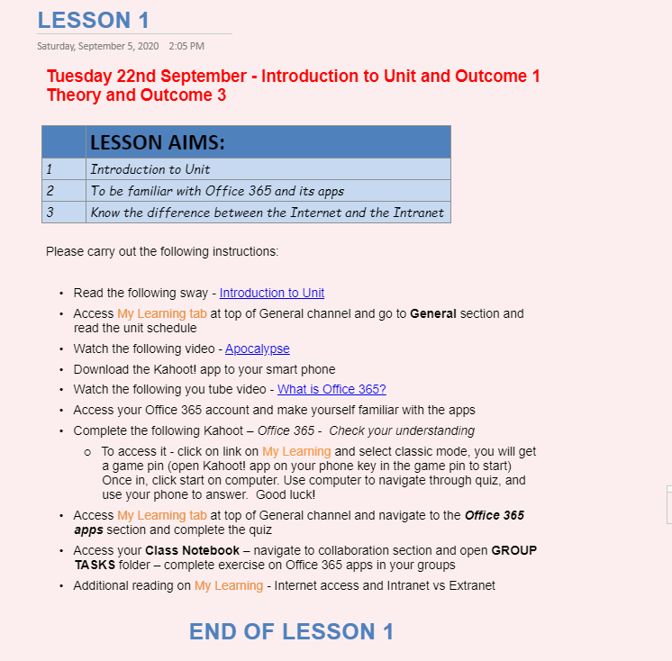
- I used Class Notebook to store all my Lesson plans – all Lessons Plans were created in advance of delivery allowing students to access learning materials in an orderly manner. Giving students control of their Learning with some even looking at materials in advance of classes, giving them a great understanding during delivery and improving flexibility of delivery.

- All lessons were delivered live – at beginning I would have half the class in and the other half joining remotely – virtual classroom was created. This helped to sharpen students’ digital skills.

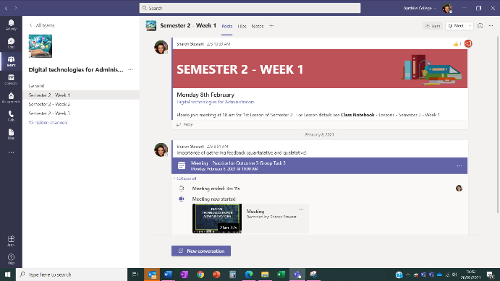
- All lessons were recorded which allowed students who may have missed lessons to go back and watch at a later day/time – each lesson stored in appropriate channel.

- My Learning embedded in Team page so everything in one place, making it easy for students to locate resources
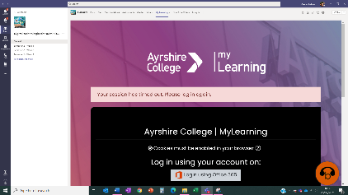

- Use of Bitmojis within my Team page to create and build a colourful virtual environment making it a welcoming environment.

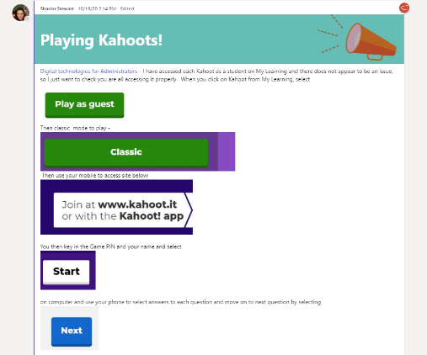
- Use of Kahoot quizzes to test elements of
and understanding – injecting element of fun into
delivery encouraging engagement and motivation

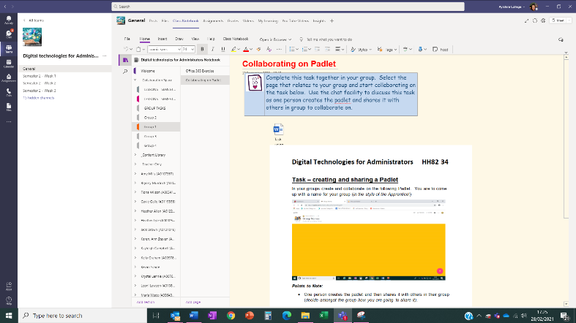
- Set up Class Notebook to provide a collaboration space to allow students to work in groups and collaborate on tasks. This helped to build relationships in class and allowed students to make individual progress in tandem with others in their group, all working towards a common goal. This helped to make them accountable to one another and encouraged them to self-manage their tasks – flipping the classroom.

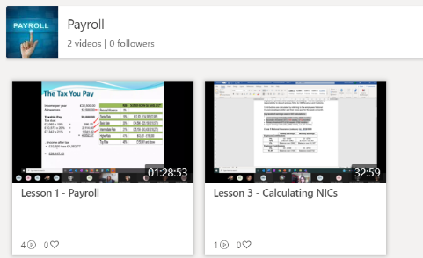
Delivery of Payroll
- To support all live lessons I created short videos on each skill student was to master eg how to use planner app in teams and in my opinion helped to improve retention of information and increase engagement.

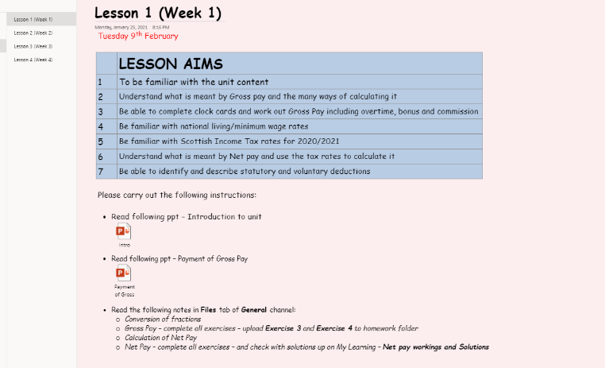
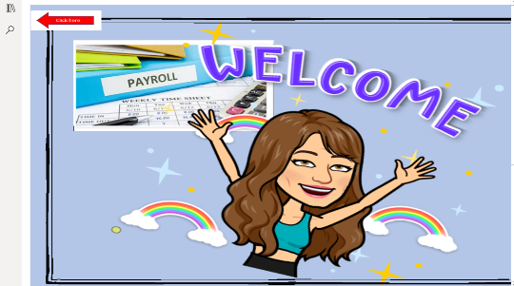
- I used Class Notebook to store all my Lesson plans – all Lessons Plans were created in advance of delivery allowing students to access learning materials in an orderly manner. Giving students control of their Learning with some even looking at materials in advance of classes, giving them a great understanding during delivery and improving flexibility of delivery.

- All lessons were delivered live – virtual classroom was created.

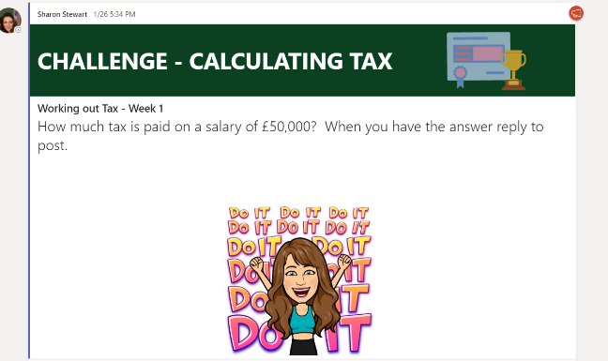

- Posting Challenges within Teams to create a competitive environment and keep students motivated and engaged.

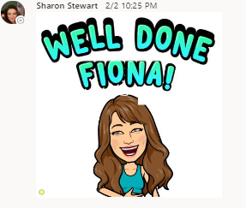
- All lessons were recorded which allowed students who may have missed lessons to go back and watch at a later day/time and so no learning missed.

- My Learning embedded in Team page so everything in one place

- Use of Bitmojis within my Team page to create and build a colourful virtual environment making it a welcoming environment for all students encouraging them to engage.

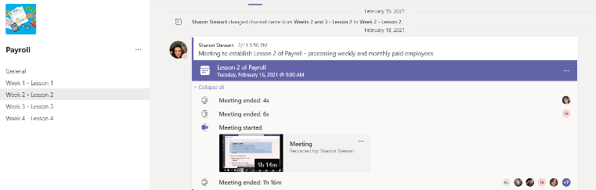
- Ensuring recorded lessons are stored in
weekly channels making it easy for students
to locate.
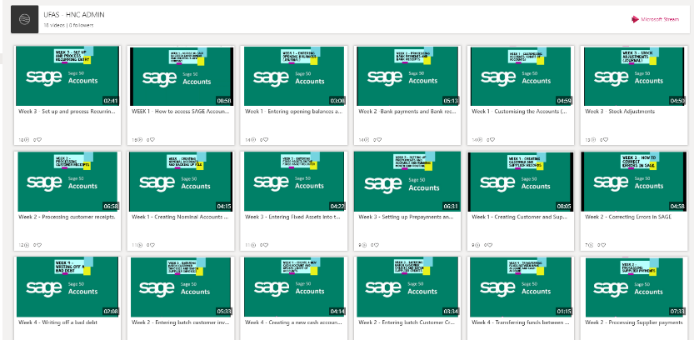
Delivery of UFAS

- To support all live lessons I created short videos on each process covered in SAGE Book-keeping software and in my opinion this helped to improve retention of information and increase engagement.

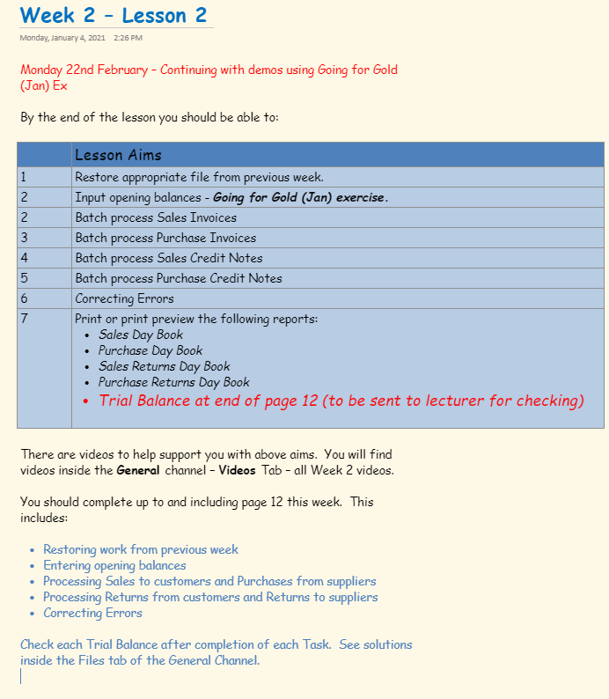
- I used Class Notebook to store all my Lesson plans – all Lessons Plans were created in advance of delivery allowing students to access learning materials in an orderly manner. Giving students control of their Learning with some even looking at materials in advance of classes, giving them a great understanding during delivery and improving flexibility of delivery.

- All lessons were delivered live – virtual classroom was created

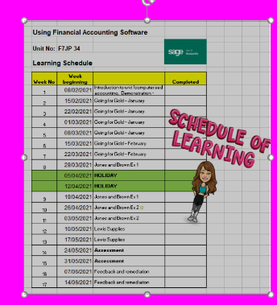
- All lessons were recorded which allowed students who may have missed lessons to go back and watch at a later day/time and so no learning missed.

- Use of Bitmojis within my Team page to create and build a colourful virtual environment making it a welcoming environment for all students encouraging them to engage.

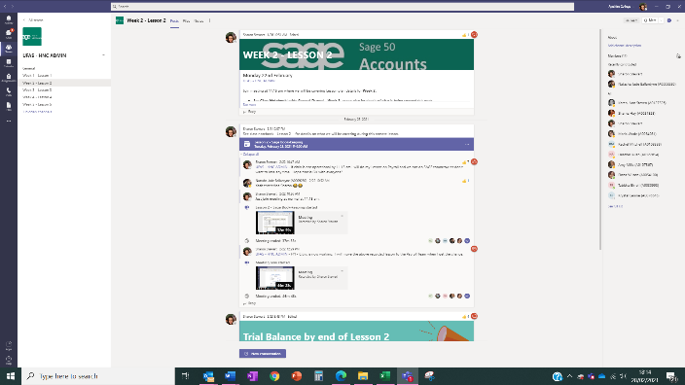
- Ensuring recorded lessons are stored in weekly channels making it easy for students to locate.

